Creating a Darwin Core Archive for LTMN data and uploading species records to the NBN Atlas

Contents
Introduction 1
Background 2
Storing data in a DwC-A 5
Create files for the NBN Atlas 5
Stage 1: Run R Script 5
Stage 2: Clean and check occurrence CSV 6
Stage 3: Undertake species match 7
Stage 4: Create zip file to send to NBN 7
Stage 5: Update Measurement or Fact 7
Appendix A: Occurrence Template 8
Appendix B: Measurement or fact template 11
Appendix C – EML.XML 12
Appendix D: Identification verification rules 16

Introduction

LTMN currently has over 400,000 species records that could be uploading to the NBN Atlas, with thousands more collected each year. Data can be submitted to NBN atlas (see here) using the Darwin Core (DwC) standard, normally through the creation of a Darwin Core Archive (DwC-A).
All LTMN species data will be stored in a DwC-A format, however NBN cannot work with this structure so we will create a slightly amended occurrence datafile for the Atlas.
Data will be uploaded on a yearly basis, once the data from the surveys has become available on the Access to Evidence catalogue. NBN doesn’t accept incremental updates so we will have to re-upload everything each year.
This document provides technical information on how to store Long Term Monitoring Network (LTMN) species data in a Darwin Core Archive (DwC-A) and create the required files for upload to the NBN Atlas.

Background

NBN is the UK Node for the Global Biodiversity Information facility (GBIF), who provide most of the guidance for creating DwC-A’s. DwC-A is a data standard that produces a single, self-contained dataset for sharing species level occurrence data and sampling event data. It consists of:
- A core data file with numerous extensions (.csv using DwC terms).
- A metafile (.xml) which describes how the files in (1) are linked e.g. through GUID’s
- A resource metadata document (.eml.xml) which provides information about the dataset itself such as an abstract, authorship, publication, collection methods etc. Uses Ecological Metadata Language profile.

There are multiple ways to generate a DwC-A:
- Publishing using the Integrated Publishing Toolkit (IPT)
This seems to be the most common way to publish your data once it’s in .csv format with DwC fieldnames. You need to request a free account on a trusted data hosting centre. It outputs a DwC-A and supports automatic registration in the GBIF network. I didn’t find a centre that was hosted in the UK so have not requested a free account yet (as most specify they only help from organisations within that country). Hence, I am discounting this method.
- Publishing using a GBIF SS Template
GBIF provide a set of pre-configured Microsoft excel templates for occurrence, sampling-event and checklist data (much like the NBN templates). To publish as a DwC-A, you still need to upload to IPT. We will not have access to IPT so discounting this option.
- Publishing manually
DwC-A can be created without any dedicated software. We could potentially automate this process using an access database, python and some xml libraries if we so wish. Requires three steps:
3.1) Create CSV files for core and extension data (single file for each). Can be done in Access, Python or manually.
3.2) Then we need to create the metafile (XML)
1) Create manually using an XML editor and sample metafiles.
2) Create using the online application Darwin Core Archive Assistant. NOTE: this tool doesn’t support Event-sampling core data files and is no longer supported by GBIF.
3.3) Finally, create the resource metadata document (.eml.xml). Guides are provided.

It is this third option that we have chosen. The Central idea of the archive is that the data files are organised in a star-like manner, with one ‘core’ datafile surrounded by any number of ‘extensions’.
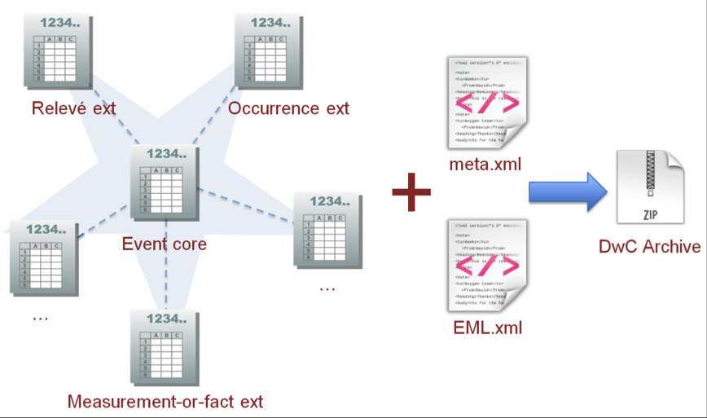

For LTMN purposes, this translates into the following structure:
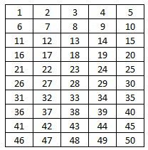
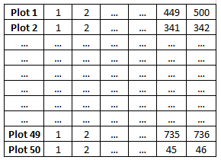
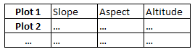
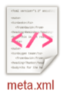
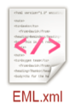
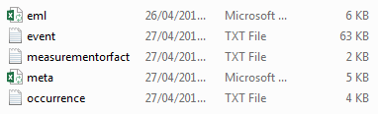
Event (core)
Occurence (extension)
Measurement or Fact (extension)
CSVs
eventID
eventID
XMLs

Storing data in a DwC-A

Species data from the LTMN surveys are stored in Excel spreadsheets on the Access to Evidence catalogue (under the species tab). Using the R code provided on TRIM, we can extract this data into the right format for the NBN Atlas. For our purposes, we create a slightly slimmed down version of the DwC-A as described in the image above – the NBN Atlas do not accept the Event as the core so we are creating just an occurrence textfile (so not a full DwC-A) which means we have to manipulate the occurrence textfile to hold a few extra fields from the event. We will also provide the EML document as well as a separate file for the measurement or fact data to be held on A2E catalogue. This new structure is displayed below.
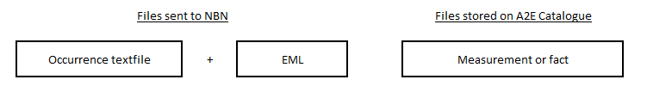
It is envisaged that this will be done annually, on a site by site basis.
The occurrence file template can be seen in Appendix A, Measurement of Fact in Appendix B and a copy of the EML XML file (which shouldn’t need to be edited unless fields are to be changed) is in Appendix C.
The current versions of Measurement of Fact and the EML can also be found on TRIM.

Create files for the NBN Atlas

Stage 1: Run R Script

The occurrence file be created within R using the script provided on TRIM.

The R script does the following:
- Loads in the Plot and Species data
- Adds additional fields to plot table
  - Coordinates converted to Latitude + Longitude
  - Event ID (needs to be a GUID)
  - Site abbreviation code
  - Location ID (main identifier)
  - Add survey date in ISO 8601 format.
- Creates blank occurrence table (with same template as in Appendix A)
- Populates the occurrence table
- Add Verification status (see below)
- Exports to CSV

There are a couple of QA checks to keep an eye for this process to work.
- The ‘SDATE’ field on the Plot tab of the survey SS must be a ‘Date’ and of the format DD/MM/YYYY
- If there are empty cells for ‘CELL_1’ to ‘CELL_25’ in the species tab, then the ‘individualCount’ field will not be calculated in R
- Sometimes values for ‘CELL_1’ to ‘CELL_25’ are uploaded as a character rather than numeric. Use the following R Code for this (replace X with CELL of interest)
species$CELL_X <- as.numeric(as.character(species$CELL_X)

Before running the code, we need to update some fields that are unique to each site (highlighted by ###### MANUAL change comment in the code). A lot of these fields can be found in the Master Audit Spreadsheet.

- Site abbreviation (line 48)
- Site footprint (Line 156). The current list can be found on TRIM.

If you need to create a bounding box for a new site then see below.
Select all the plots in this layer for the site of interest. Run the ‘Collect geometries’ tool and then the ‘Bounding boxes’ tool on the output. Save this output as a CSV making sure the geometry is as a WKT. This WKT can then be appended to the current list.
- Site locality (line 164)
- Survey type and quality assurance tag (line 202-203). These are found in the Master Audit and described below.

The last part of this process is to add the verification status rules. These describe how confident we are in the species data and use a set of rules described in Appendix C and are based on the SurveyType and qualityAssurance tags described above. SurveyType can either be ‘IN_HOUSE’ or ‘CONTRACT’ and qualityAssurance is ‘YES’ if the site was survey in 2015 or later, and ‘NO’ if surveyed pre 2015.

Stage 2: Clean and check occurrence CSV

Using the CSV exported form stage 1 we need to undertake some QA checks.
- Remove ID and DataCode fields.
- Check no duplicates in occurrence ID field.
- Check that date field is correctly populated and no empty cells.
- Check no empty cells in identificationVerificationStatus.
- Add P to the location ID field e.g. B01_AIN_2012_2 should become B01_AIN_2012_P2
- Check all fields have no empty cells
- Check individualCounts have been calculated. If original data contain an empty cell or a character these will not have been.
- Check percent Frequency field doesn’t have values > 100%. If so, make it 100%.
- GEOGRAPHIC CHECK: Upload all Latitude and Longitude coordinates into QGIS to check they all fall within the bounding boxes we provide.

If you have multiple sites, then repeat Stage 1 and 2 are all sites before merging the occurrence CSVs together (this can be done manually or using windows command line copy). You can then use this overall file for the rest of the stages.

Stage 3: Undertake species match

Once cleaned, the occurrence data is ready to have its species matched. This process will provide the correct species name and a unique taxon code that the NBN require.
- Remove all fields apart from occurrence_ID and species.
- Due to limitations with the tool used for matching the species we can only upload 500 records at a time for checking, and it must be in an .xlsx format. To split your file into 500 record chunks use the split.py file found in the TRIM folder. These will then need to be saved into an excel document.

- In the returned spreadsheet, remove those where type of match is ‘none’. This process could be improved to ensure more species are matched but didn’t have time when doing this for the initial 70 surveys).
- If working on more than one site, merge the .xlsx back into one document using the following script.

- Join the species name and Taxon ID field back to the original occurrence CSV.

Stage 4: Create zip file to send to NBN

Undertake some final checks on the CSV (non-empty cells, all data is of the correct format, occurrence_ID is unique etc.) and then save it as a textfile. This can be zipped up with the EML document and sent to Sophie Ratcliffe at the NBN (s.ratcliffe@nbn.org.uk).

Stage 5: Update Measurement or Fact
The measurement or fact data is stored in a spreadsheet and needs to have data appended to it for each new site we create an occurrence file for. This currently sits on the A2E LTMN page and is referenced through the EML.

Appendix A: Occurrence Template

DwC Field | Source | Required | Definition | Default Values | Notes
id | GUID | YES |  |  | Same as eventID
occurrenceID | GUID | YES | The unique, and persistent, key or ID of the record
eventID | GUID | YES | An identifier for the set of information associated with an Event |  | Same as id
collectionCode | User input | NO | The name, acronym, code, or initialism identifying the collection or data set from which the record was derived. | LTMN
datasetName | User input | YES | The title given to the NBN Atlas data resource that the record belongs to | Long-Term Monitoring Network Vegetation Quadrats
institutionCode | User input | YES | The name (or acronym) of the data partner of the record. | Natural England
license | User input | YES | A legally binding licence giving official permission to do something with the resource. | OGL
rightsHolder | User input | YES | A person or organisation owning or managing rights over the resource. | Natural England
scientificName | User input | YES | The full scientific name (authorship and date information should be included if known
taxonID | User input | YES | The Taxon Version Key (TVK) for the species, as supplied by the UK Species Inventory
identificationVerificationStatus | User input | YES | Description of the extent to which the taxonomic identification has been verified to be correct.
eventDate | Direct from data (PE_DATE) | YES | The date or interval during which an Event occurred.
recordedBy | User input | YES | Names of people, groups, or organisations responsible for recording the original Occurrence. | LTMN Surveyors
identifiedBy | Direct from data (SURVEYOR) | NO | A list of names of people, groups, or organisations who assigned the taxon to the subject.
coordinateUncertaintyInMeters | User input | YES | The horizontal distance (in meters) from the given decimalLatitude and decimalLongitude describing the smallest circle containing the whole of the Location | 1
decimalLatitude | Calculated from data | YES | The geographic latitude (in decimal degrees, using the spatial reference system given in geodeticDatum) of the geographic center of a Location. Positive values are north of the Equator, negative values are south of it. Legal values lie between -90 and 90, inclusive.
decimalLongitude | Calculated from data | YES | The geographic longitude (in decimal degrees, using the spatial reference system given in geodeticDatum) of the geographic centre of a Location. Positive values are east of the Greenwich Meridian, negative values are west of it. Legal values lie between -180 and 180, inclusive.
sampleSizeValue | User Input | YES |  | 4
sampleSizeUnit | User Input | YES |  | square_metre
footprintWKT | User input | YES
locationID | ID | YES | An identifier for the set of location information
locality | User input | YES | The specific description of the place, or place name. | Ainsdale NNR
basisOfRecord | User Input | YES | The nature of the record. In most cases this is ‘HumanObservation’. Other possible values are: | Human Observation
occurrenceStatus | User input | YES | The presence or absence of individuals in the occurrence. | Present
individualCount | Direct from data (SUM of cell count) | NO | The number of individuals represented present at the time of the occurrence. |  | Actual count
organismQuantity | Calculated from data | NO | A number or enumeration value for the quantity of organisms. The type of value is described by the organismQuantityType term. |  | Formula for calculating % cover
organismQuantityType | Calculated from data | NO | The type of quantification system used for the quantity of organisms. | Percent Cover | Used to describe % cover

Appendix B: Measurement or fact template

Field | Source
site | User input
abbreviation | User input
year | User input
plotID | Collected from data
locationID | Collected from occurrence
slope | Collected from survey
aspect | Collected from survey
altitude (metres) | Collected from survey
plotNotes | Collected from survey

Appendix C – EML.XML

<?xml version="1.0" encoding="UTF-8"?>
<eml:eml
xmlns:eml="eml://ecoinformatics.org/eml-2.1.1"
xmlns:stmml="http://www.xml-cml.org/schema/stmml-1.1"
xmlns:xsi="http://www.w3.org/2001/XMLSchema-instance" packageId="d0a2a058-4244-11e8-bf93-937f35fa6cee" system="uuid" xsi:schemaLocation="eml://ecoinformatics.org/eml-2.1.1 eml.xsd">
<dataset>
<title>Long-Term Monitoring Network Vegetation Quadrats
</title>
<creator>
<individualName>
<givenName>Rob</givenName>
<surName>Keane</surName>
</individualName>
<organizationName>Natural England</organizationName>
<positionName>Lead Advisor</positionName>
<address>2nd floor, Arndale House, Manchester Arndale, Manchester, M4 3AQ</address>
<phone>02080261833</phone>
<electronicMailAddress>Rob.Keane@naturalengland.org.uk</electronicMailAddress>
</creator>
<creator>
<individualName>
<givenName>Nathan</givenName>
<surName>Shaw</surName>
</individualName>
<organizationName>Natural England</organizationName>
<positionName>GI Lead Advisor</positionName>
<address>Murley Moss Business Village, Oxenholme Rd, Kendal, Cumbria, LA9 7RL</address>
<phone>02084152999</phone>
<electronicMailAddress>nathan.shaw@naturalengland.org.uk</electronicMailAddress>
</creator>
<pubDate>2018</pubDate>
<language>eng</language>
<abstract>This dataset includes the results of vegetation quadrat surveys collected for the Long-Term Monitoring Network. Surveys were conducted by a mixture of volunteers, Natural England staff, and paid contractors, using a standard protocol (see http://publications.naturalengland.org.uk/category/5895911152025600) and a range of quality assurance procedures. </abstract>
<keywordSet>
<keyword>LTMN</keyword>
<keyword>Long term Monitoring Network</keyword>
<keyword>Plants</keyword>
<keyword>Time-series</keyword>
</keywordSet>
<additionalInfo>Natural England’s Long-term Monitoring Network project (LTMN) began in 2009 with the aim of developing, with our partners, a cost effective network of sites to provide evidence on the effects of changing climate, air pollution and land management on the natural environment. LTMN measures multiple attributes on 37 fixed sites across England (http://publications.naturalengland.org.uk/map?category=5316639066161152), using standard protocols (http://publications.naturalengland.org.uk/category/5895911152025600). It covers ten target habitats and similar habitats can be compared in areas with contrasting climate and pollution conditions.</additionalInfo>
<intellectualRights>OGL</intellectualRights>
<coverage>
<geographicCoverage>
<geographicDescription>Surveys were carried out at fixed quadrat locations on 37 National Nature Reserves across England. See http://publications.naturalengland.org.uk/map?category=5316639066161152. Surveys were carried out between May and September in each survey year, initially to establish baseline data and then repeat measurement surveys normally every four years. Baseline surveys were conducted from 2010 to 2015, repeat measurement surveys from 2013. Further site and plot information such as slope, aspect, elevation can be found here (http://publications.naturalengland.org.uk/publication/4654364897050624) by using the LocationID stored for each record on the NBN Atlas.
</geographicDescription>
<boundingCoordinates>
<westBoundingCoordinate>-5.8884</westBoundingCoordinate>
<eastBoundingCoordinate>1.803</eastBoundingCoordinate>
<northBoundingCoordinate>55.8916</northBoundingCoordinate>
<southBoundingCoordinate>49.9325</southBoundingCoordinate>
</boundingCoordinates>
</geographicCoverage>
<temporalCoverage>
<rangeOfDates>
<beginDate>2010</beginDate>
<endDate>2018</endDate>
</rangeOfDates>
</temporalCoverage>
<taxonomicCoverage>
<generalTaxonomicCoverage>Recording should use the standard abbreviated names for plant species in the UK. Species names conform to Flora Europaea, which should be used as the standard for vegetation recording. Each species has an associated unique code number, used by the National Vegetation Classification system (see Malloch 1988 - available from: Institute of Environmental and Biological Sciences, University of Lancaster, Lancaster LA1 4YQ, UK). For those genera whose species are considered difficult to distinguish, the genus name only may be recorded.
</generalTaxonomicCoverage>
<taxonomicClassification>
<taxonRankName>Genus</taxonRankName>
<taxonRankValue>Species</taxonRankValue>
</taxonomicClassification>
</taxonomicCoverage>
</coverage>
<contact>
<individualName>
<givenName>Rob</givenName>
<surName>Keane</surName>
</individualName>
<organizationName>Natural England</organizationName>
<positionName>Lead Advisor</positionName>
<address>2nd floor, Arndale House, Manchester Arndale, Manchester, M4 3AQ</address>
<phone>02080261833</phone>
<electronicMailAddress>Rob.Keane@naturalengland.org.uk</electronicMailAddress>
</contact>
<methods>
<methodStep>
<description>See http://publications.naturalengland.org.uk/publication/6331137473904640?category=5895911152025600</description>
</methodStep>
<sampling>
<studyExtent>
<description>Surveys were carried out at fixed quadrat locations on 37 National Nature Reserves across England.</description>
</studyExtent>
<samplingDescription>See http://publications.naturalengland.org.uk/publication/6331137473904640?category=5895911152025600</samplingDescription>
</sampling>
<qualityControl>
<description>A number of quality control procedures were applied, including validation, identification and coding of data issues, quality assurance processes to rectify errors or remove unreliable data, sample checking, and internal and expert review. Verification Status was asigned using a set of rules. If the survey was undertaken by a contractor, then all records are ACCEPTED. If the survey was completed by Natural England but hasn't undergone the complete QA process, records are marked as ACCEPTED - CONSIDERED CORRECT. If the survey was completed by Natural England and has undergone the complete QA process, statuses are assigned based on QA code: empty: ACCEPTED; 999: ACCEPTED; QA600: ACCEPTED; QA601: ACCEPTED; QA602: ACCEPTED; QA603: ACCEPTED; QA604: ACCEPTED; QA605: ACCEPTED; QA606: ACCEPTED; QA607: ACCEPTED; QA608: ACCEPTED; QA610: ACCEPTED; QA766: UNCONFIRMED; QA777: ACCEPTED; QA788: UNCONFIRMED; QA900: ACCEPTED; QA901: ACCEPTED; QA902: ACCEPTED; QA903: ACCEPTED; QA999: UNCONFIRMED.
</description>
</qualityControl>
</methods>
</dataset>
</eml:eml>

Appendix D: Identification verification rules

Created by Andy Webb, these rules populate the identificationVerificationStatus field.
Survey
In -house
Contract
ACCEPTED
QA’D
Not QA’D
ACCEPTED – CONSIDERED CORRECT
Follow rules below

Code | identificationVerificationStatus
empty | ACCEPTED
999 | ACCEPTED
QA600 | ACCEPTED
QA601 | ACCEPTED
QA602 | ACCEPTED
QA603 | ACCEPTED
QA604 | ACCEPTED
QA605 | ACCEPTED
QA606 | ACCEPTED
QA607 | ACCEPTED
QA608 | ACCEPTED
QA610 | ACCEPTED
QA766 | UNCONFIRMED
QA777 | ACCEPTED
QA788 | UNCONFIRMED
QA900 | ACCEPTED
QA901 | ACCEPTED
QA902 | ACCEPTED
QA903 | ACCEPTED
QA999 | UNCONFIRMED

